Alphabet Soup Charity Deep Learning Model Analysis

Module 21 Challenge – Deep Learning

By Jonathon Wood

3rd May 2023

**Overview of the Analysis**

The purpose of this analysis is to create a deep learning neural network model to predict whether applicants for funding from the Alphabet Soup Charity will be successful in using the funds effectively. The model aims to achieve a predictive accuracy higher than 75%.

**Results**

## Data Pre-processing

Target variable for the model:

**IS_SUCCESSFUL**

Feature variables for the model:

**APPLICATION_TYPE**,

**AFFILIATION**,

**CLASSIFICATION**,

**USE_CASE**,

**ORGANIZATION**,

**STATUS**,

**INCOME_AMT**,

**SPECIAL_CONSIDERATIONS**,

**ASK_AMT**

Variable(s) removed from the input data:

**EIN**,

**NAME**

## Compiling, Training, and Evaluating the Model

Number of neurons, layers, and activation functions selected for the neural network model:

Neurons: 128 neurons per layer based on the optimized model

Layers: 1 input layer based on the optimized model

Activation functions: ReLU for hidden layers, Sigmoid for output layer

## Reasoning for the selected architecture:

Based on the optimization results, the chosen architecture has 1 hidden layer, 128 neurons per layer, and uses the Stochastic Gradient Descent (SGD) optimizer. This configuration was selected because it achieved the highest accuracy among all tested combinations, with an accuracy score of approximately 0.7303. The heatmap and bar plots provided valuable insights into the model's performance across various configurations.

In summary, the selected architecture provides a good balance between model complexity and performance, achieving the highest accuracy while maintaining stability across various configurations.

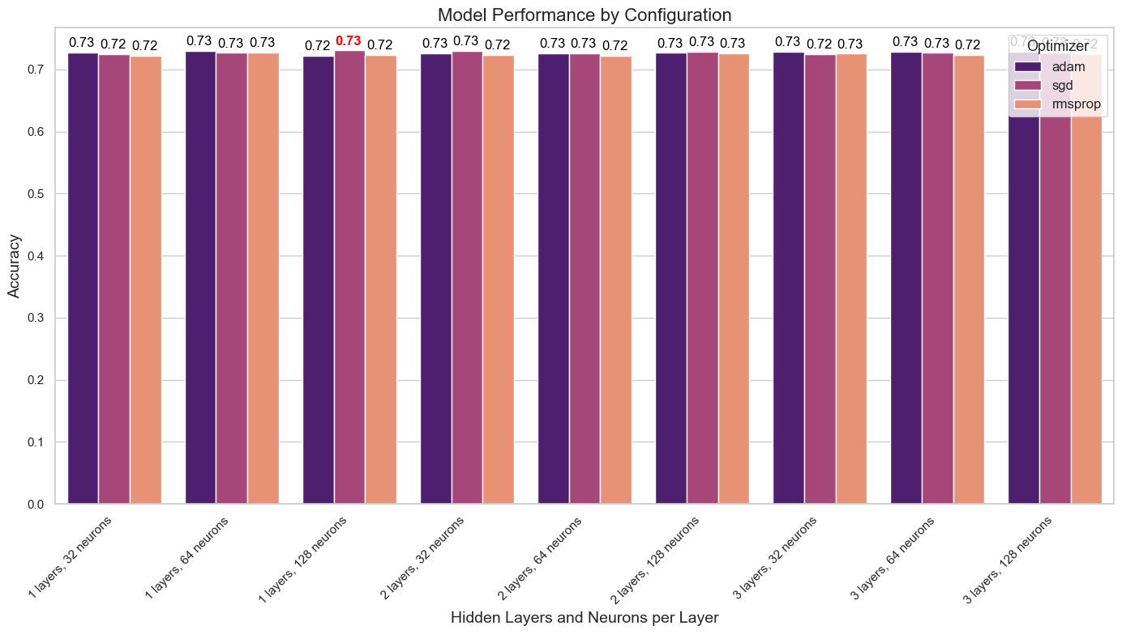

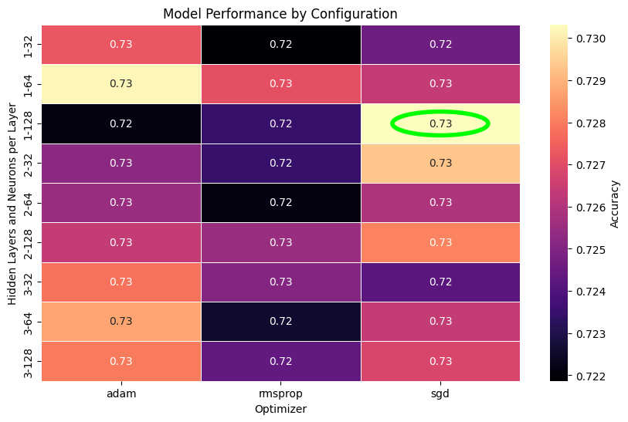

## Optimal Model performance:

Loss: 0.553783

Accuracy: 0.730321

## Steps taken in attempts to increase model performance:

Experimented with different numbers of hidden layers: 1, 2, and 3.

Experimented with varying numbers of neurons per layer: 32, 64, and 128.

Tested different optimizers: 'adam', 'sgd', and 'rmsprop'.

Utilized 'relu' activation functions for hidden layers and 'sigmoid' activation function for the output layer.

Performed a comprehensive search using the combinations of the above parameters to identify the optimal configuration.

Analyzed the results using a heatmap and violin plots to visualize the performance of various configurations and identify the best model.

By systematically exploring different configurations of hidden layers, neurons per layer, and optimizers, we were able to identify the optimal architecture for this specific problem, which resulted in the highest achieved accuracy.

**Summary**

In this project, we aimed to create a deep learning model to predict the success of charitable organizations based on their features. We preprocessed the data, identified target and feature variables, and removed unnecessary columns. The data was split into training and testing sets and scaled using a StandardScaler.

We built a neural network model and experimented with different configurations of hidden layers, neurons per layer, and optimizers. By analyzing the results using a heatmap and violin plots, we identified the optimal architecture for this problem, which achieved a loss of 0.553783 and an accuracy of 0.730321.

The best model parameters were:

Hidden Layers: 1

Neurons per Layer: 128

Optimizer: sgd

Despite best efforts to optimize the model, we could not achieve an accuracy of 75% or higher. This could be due to several factors, such as the limitations of the dataset, the complexity of the problem, or the choice of the model architecture. To further improve the model performance, other approaches such as different architectures, more advanced optimization techniques, or additional feature engineering could be explored.

It is also possible that the current features in the dataset might not be sufficient to accurately predict the success of charitable organizations, and incorporating additional relevant features could help improve the model's accuracy.

Overall, the deep learning model provided a reasonable level of accuracy in predicting the success of charitable organizations, which can be useful for decision-making processes in the non-profit sector. However, further improvements and exploration of alternative approaches might be necessary to achieve the desired accuracy level.